#sayYESS  Join DCIL/YESS in the third annual Embrace Your Disability Conference. YESS aims to educate the community about disability and empower youth age 14-24 to be extraordinary.  DCIL and YESS Mission Statement  The Dakota Center for Independent Living believes in empowering people with disabilities by minimizing barriers, advocating for inclusion and promoting consumer choice.  WE BELIEVE that diverse and fully inclusive organizations empower individuals, heal communities, and create a better world for all of us.  We Envision an inclusive society in which youth with disabilities have the access, support, and confidence to achieve their full potential. We believe that youth with disabilities who are educated, mentored, and empowered have a profoundly positive impact on their communities and the world. | Questions?  - Call/Text President of YESS, Jacey Enget @ 701-400-2153  - Vicki @701-222-3636 (DCIL coordinator)  youthempoweringsocialstatus@gmail.com  vickil@dakotacil.org  FIND US ON FACEBOOK  Youth Empowering Social Status - YESS  Since 1980 | Embrace Your Disability  Attendee Registration  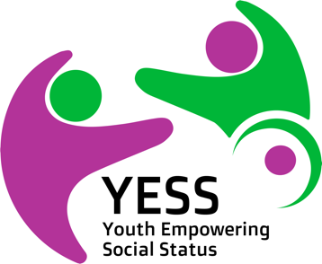  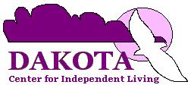  - June 18, 2021  7:30AM-4:30PM CST  Live at Bismarck Event Center and virtual via ZOOM 315 South 5th Street Bismarck, ND 58504 DOOR E-42  Prairie Rose Meeting Rooms and upper Level Lobby
KEYNOTE SPEAKERS  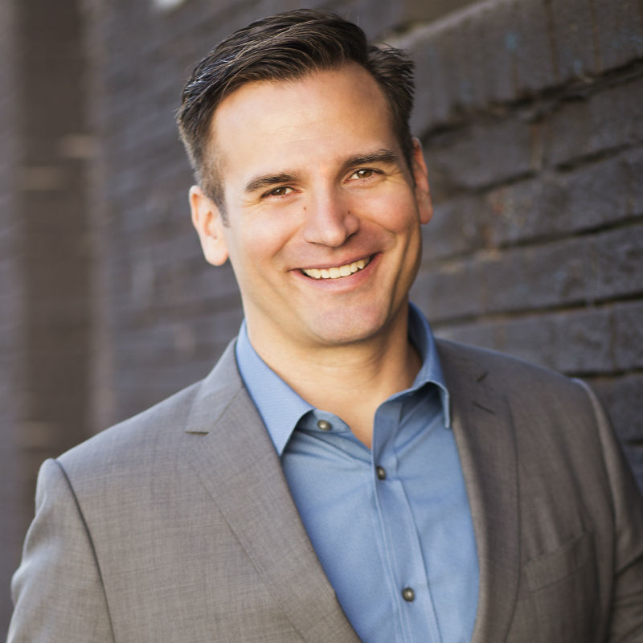  Talking about emotions can be a challenge, but Ross Szabo’s brutally honest, relatable and humorous approach puts audiences at ease as they confront a difficult topic. Ross uses tasteful humor and insights to help participants understand common mental health conditions and individual differences. He also covers warning signs that students can look for in their friends and peers, as well as resources that can provide guidance in these sensitive situations.  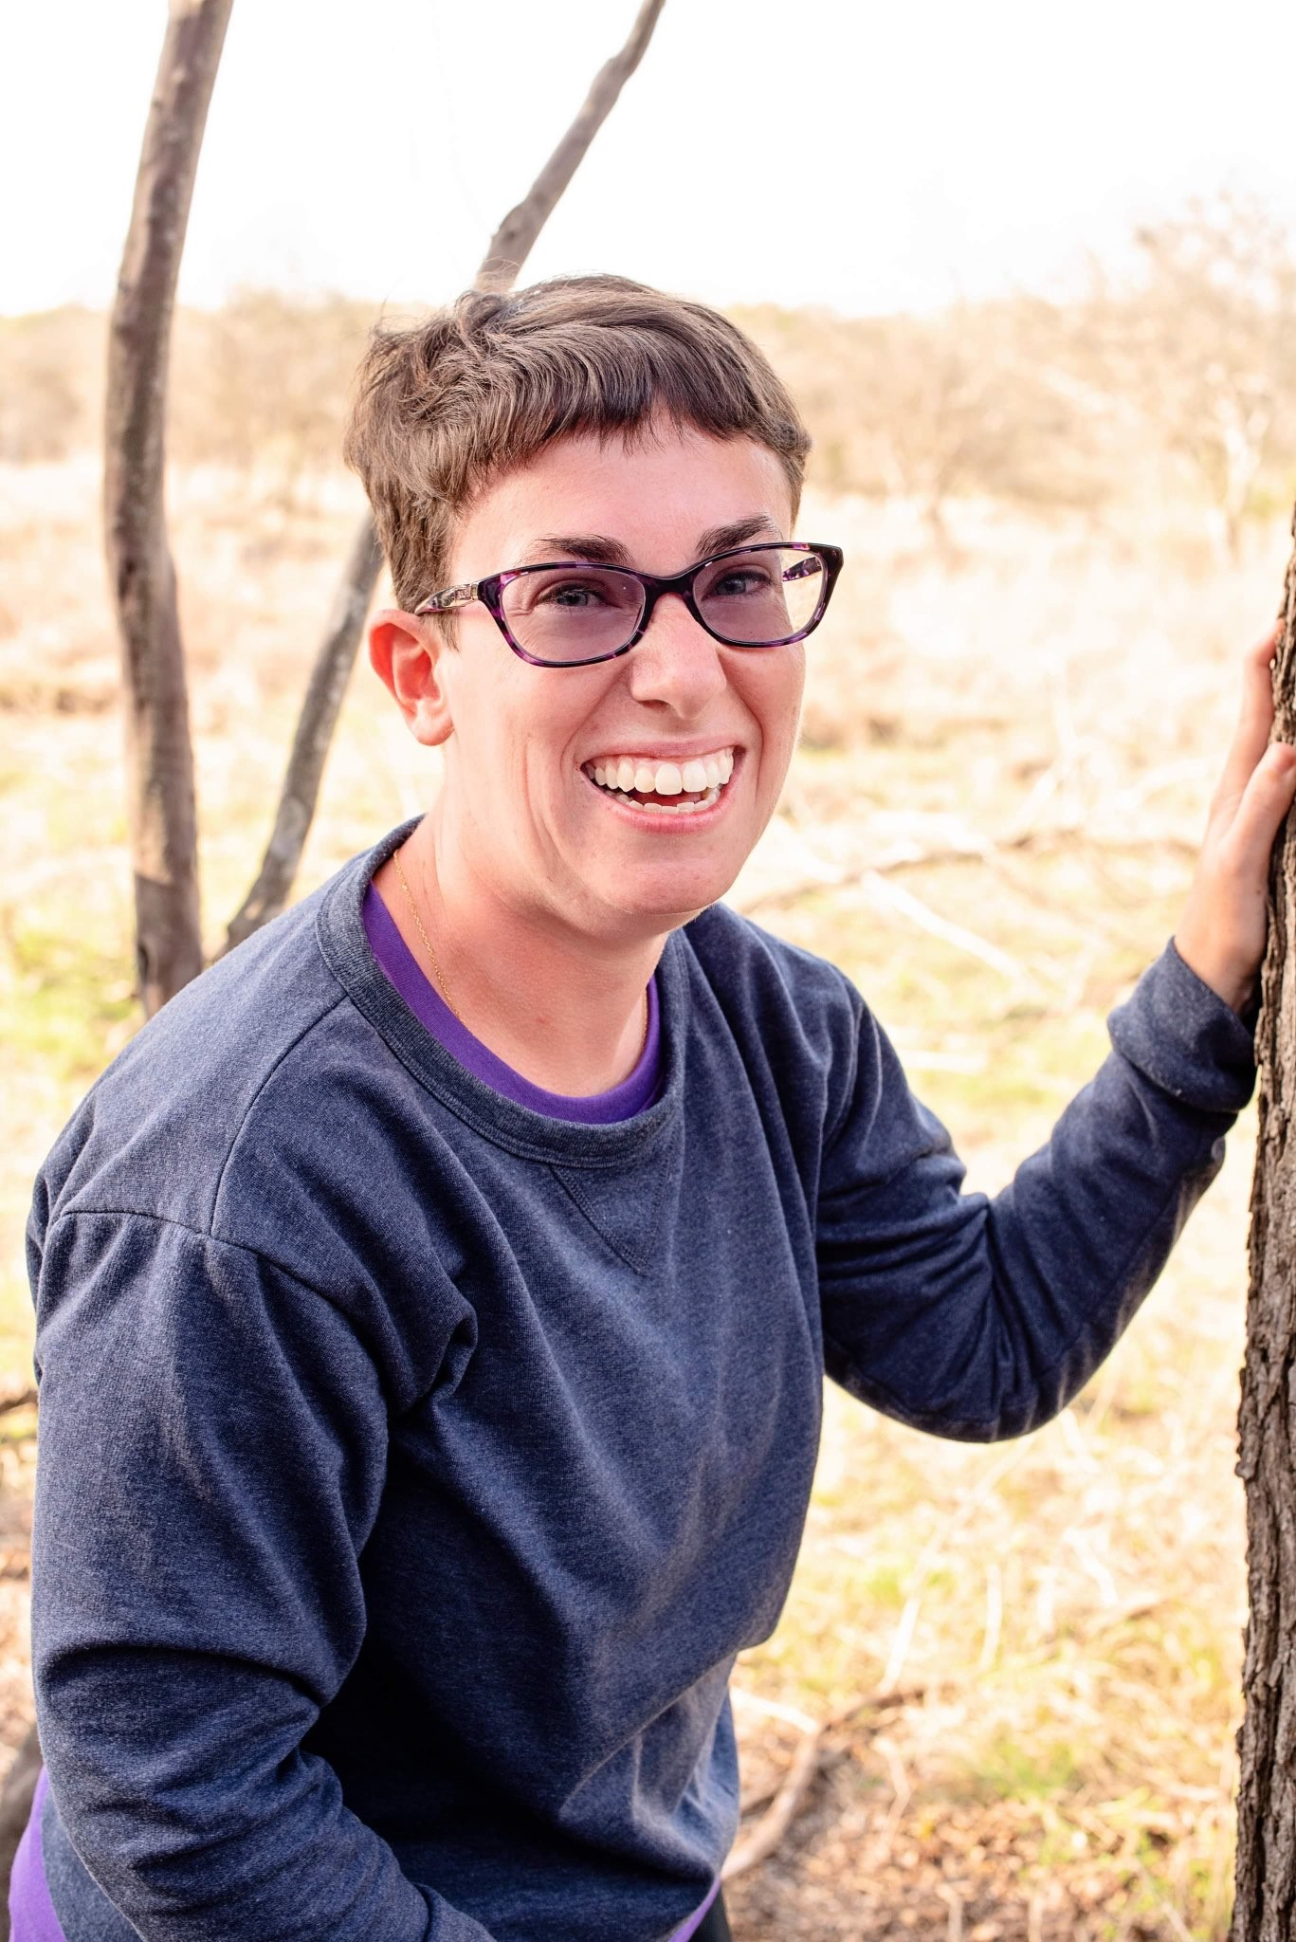 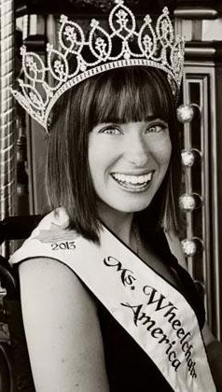 Mariah Kilbourne works full time for the University of Texas San Antonio (UTSA) Small Business Development Center (SBDC). In that role, she coordinates and organizes more than 200 annual training workshops and assists with special events. She has been honored to serve as Ms. Wheelchair Texas in 2012 & Ms. Wheelchair America in 2013. Mariah is a strong advocate for diversity and inclusion. She will be speaking from experience about inclusion, accessibility, and leadership. | LUNCH  Included in registration for those in attendence  Our food will be catered by:  Baymont Inns and Suites  Our lunch will be gluten free/dairy free.  In person lunch is not guaranteed for registration received after June 11th.  In person registration begins at 7:30 a.m. and the conference kicks off at 8:30 a.m.  You can register and pay online at our website:  Dakotacil.org  Zoom ID info will be sent after registration is received  DCIL will continue to monitor guidelines from the CDC, the North Dakota Department of Health and Bismarck Burleigh Public Health to ensure all relevant safety precautions and requirements are met. | Registration Information  First & Last Name:  Phone:  Email:  Address:  Any special accommodations need to be requested by 5/21/2021.  Make checks payable to:  Dakota Center for Independent Living  Mail above info and check to: Dakota Center for Independent Living attn. Vicki 3111 E Broadway Ave. Bismarck, ND 58501  701-222-3636  ND License Contact Hours Offered  Social Work 5.5 ☐  Nursing 6 ☐ Addiction Counseling 4.5 ☐  - $100 General or Professional  - $75 Virtual  - $20 Student/Caregiver/  People w/disabilities

