ND Protection & Advocacy Project
October 2021 Training Dates
abuse, neglect & exploitation
mandatory reporting training for
developmental disability service provider staff
October 27th 2-3:30 pm CST

Microsoft Teams meeting
Join on your computer or mobile app
Click here to join the meeting
Join with a video conferencing device
teams@join.nd.gov
Video Conference ID: 113 468 515 6
Alternate VTC instructions
Or call in (audio only)
+1 701-328-0950,,266639757# United States, Fargo
Phone Conference ID: 266 639 757#
Find a local number | Reset PIN

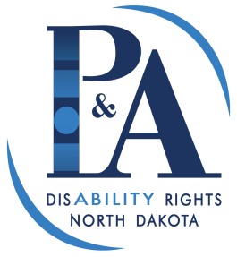
ND Protection & Advocacy Project
400 E. Broadway, Suite 409
Bismarck, ND 58501
1-800-472-2670 (701) 328-2950
www.ndpanda.org panda_intake@nd.gov

If you need this handout in an alternative format, please contact the Protection & Advocacy Project.

